OPERATORS IN SQL

1)AND

SQL > Select \* from employee where age=25 AND salary=3000;

2)OR

>SQL> Select \* from employee where age=25 OR salary=3000;

3)!=, <>

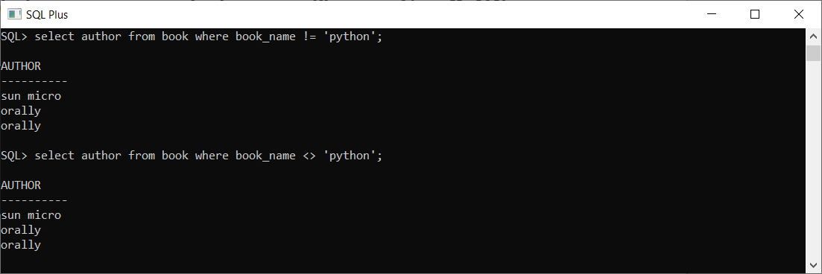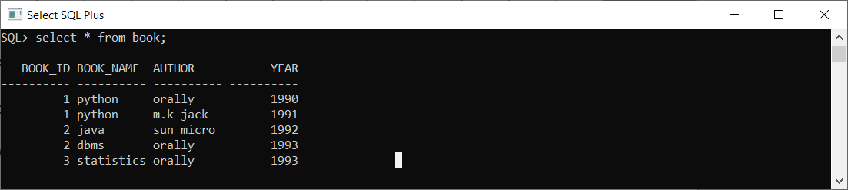

4)SET MEMBERSHIP (IN, NOT IN):

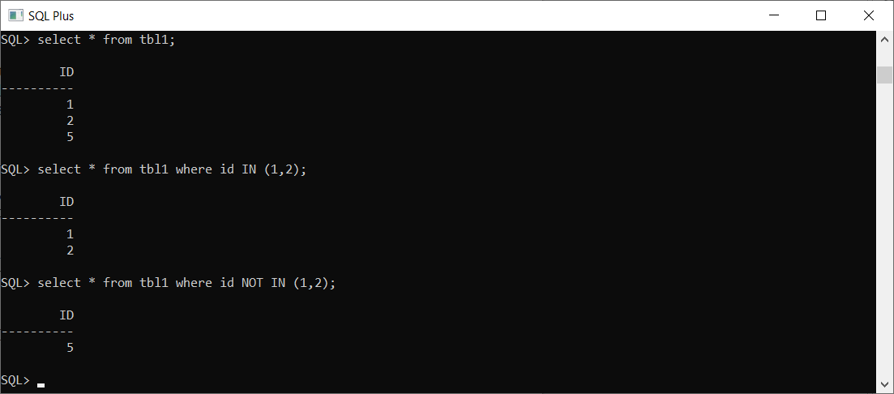

5)ALL NOT IN ALL

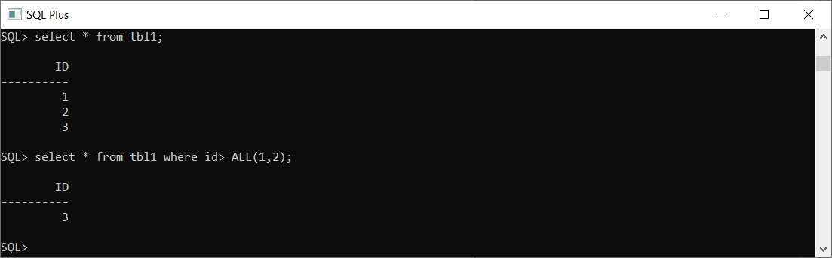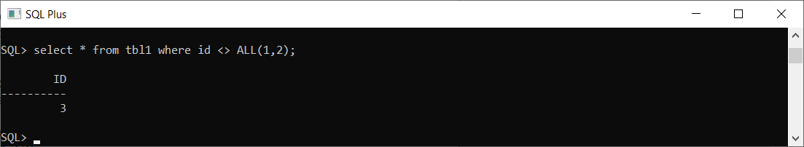

6)ANY & SOME

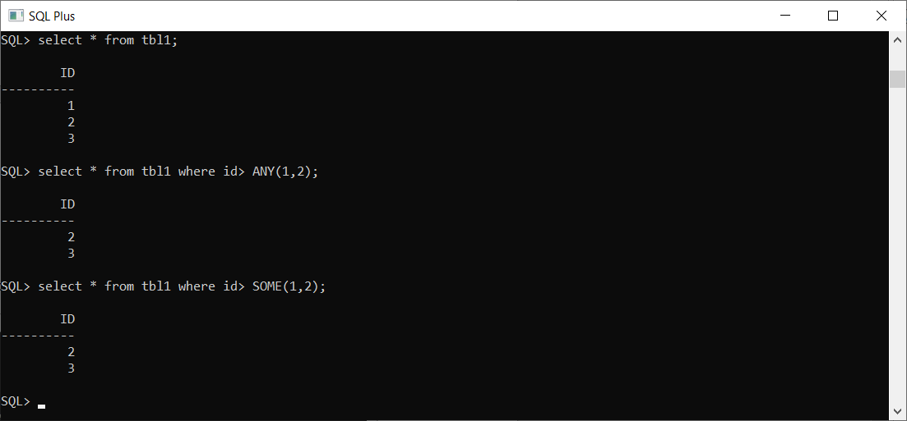

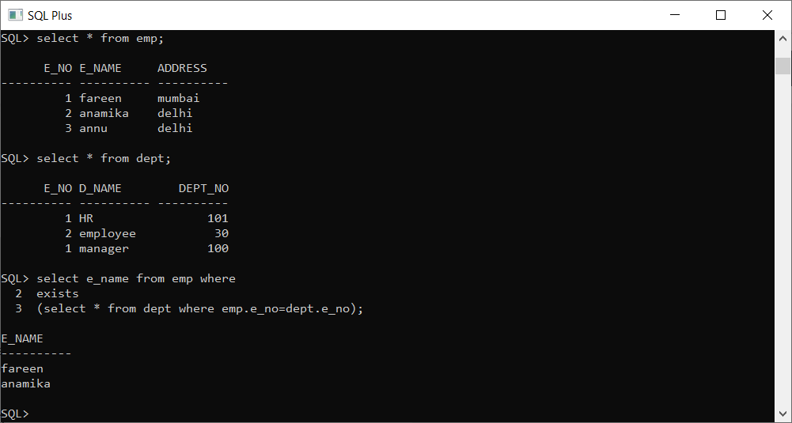7)EXIST & NOT EXIST

5)BETWEEN

SQL> SELECT \* FROM Products WHERE Price BETWEEN 10 AND 20;

Between 10 and 20(including 10 and 20).